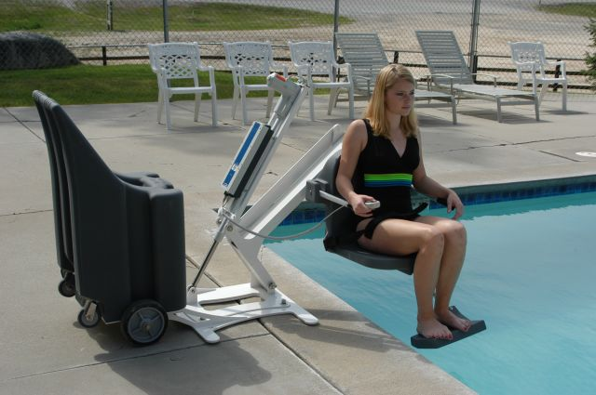
PORTABLE PRO POOL LIFT

No anchors required! Just wheel the Portable Pro Pool Lift™ up to
the poolside where you want it, tilt it forward onto the base and
start using it. The unit lifts up to 400 lbs (181kg) and has all of the
features and benefits of our standard Pro Pool Lift plus the ability to
be portable!
Standard features include:
• Unique low profile design
• Stainless Steel construction
• Submergible remote handset
• Dual flip-up arms
• Adjustable Flip-up footrest
• Adjustable lap belt
• 400 lbs (181kg) lifting capacity
• Total ship weight 995 lbs. (451kg)
• UV Resistant epoxy powder coat finish
• 24-volt rechargeable battery operation
• 5-year structural and 5-year pro-rated electronic warranty
• Ships via common carrier in two (2) separate shipments
F-004PPPB Portable Pro Pool Lift™
F-010POR Pro Pool Lift™ Portable Kit (For Retrofit)
Accessories And Add-ons
F-422PLH Pro Pool Lift™ Optional Headrest
F-444PPPC Portable Pro Pool Lift Cover
F-004AB 2 4V Additional Battery
F-044CH

The Portable Pro Pool Lift™ packs all the features of the Pro Pool Lift™ into a completely portable lift. No need to tear up your deck to install anchors, this lift is completely portable and requires no anchors!

